Teacher of Science

Candidate Information Pack

December 2023

https://www.hammersmithacademy.org/

@HammersmithAcad
@hammersmithacademy/

BACKGROUND TO HAMMERSMITH ACADEMY
@hamacad

Hammersmith Academy (“the Academy”) (www.hammersmithacademy.org) is a state-of-the-art, non-denominational, all-ability, co-educational secondary school for 11-18-year olds. Sponsored by City of London Livery Companies; the Mercers’ Company and the Information Technologists’ Company, the Academy opened in September 2011 and has now grown to approximately 920 students on roll. The Academy is oversubscribed and continues to be highly successful.

The Academy combines excellence in achievement across the curriculum with opportunity and innovation in learning approaches developed through the Academy’s specialisms in ICT and Creative and Digital Media.

HA Vision
- To develop highly qualified, aspirational young adults who make outstanding progress and as active citizens take a lead within the community and are committed to giving 100% in everything they do.

HA Values
- We inspire pride and confidence in our students to achieve their full potential. Everyone in the Academy is responsible for modelling a positive and professional attitude at all times.

- We create a stimulating and enriching learning environment where high expectations and challenge prepare students for a global society.

- We succeed by developing a growth mind-set through the skills of resilience, resourcefulness, reflectiveness and reciprocity.

An enhanced Vision and Ethos statement is provided within the information pack. The sponsors are committed to excellence in secondary education and have a track record of working with successful academies and in areas of significant academy improvement. The educational vision, building design, curriculum model and Academy organisation plan are based on the template developed successfully at Thomas Telford Academy and the Mercers’ other academies in the West Midlands combined with the Information Technologists’ experience of academy improvement at Lilian Baylis Academy in Lambeth and their expertise and industry contacts in IT and Digital and Creative Media.

The Academy has the support of, and access to, the expertise and educational networks of the Mercers’ group of schools and colleges, which includes the highly acclaimed St. Paul’s schools’ (Independent), and the Thomas Telford family of academies as well as the West London Partnership www.westlondonpartnership.org. Further details of the sponsors’ educational activities can be found on their websites www.wcit.org.uk and www.mercers.co.uk. The sponsors also have strong links with international IT industries and with the City of London.

Why choose us?
- A dynamic learning culture where your skills and attributes will be essential to its continued growth and development
- A strong, supportive staff body and leadership team
- A “can-do” culture of achievement coupled with ongoing personal and team CPD
- A well-run Academy with clear and effective processes that support professionals to lead and teach
- A commitment to well-being and support across the Academy

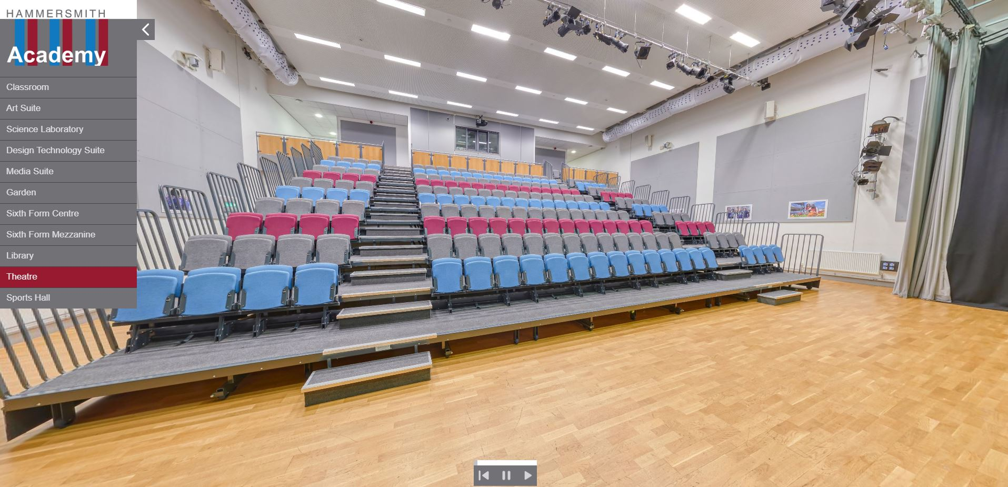

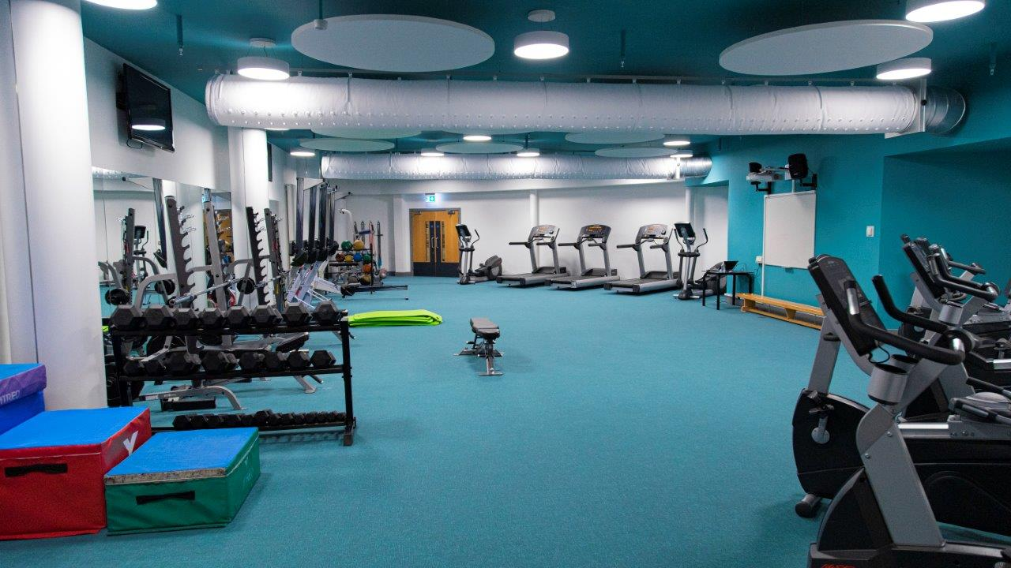

Click here for a virtual tour of the Academy: https://www.hammersmithacademy.org/about-us/virtual-tour/

APPOINTMENT OF SUBJECT TEACHER

The Headteacher and Governors of the Hammersmith Academy Trust (“the Academy”) are offering a great opportunity for an exceptional candidate to join our Science Department.

Ofsted – January 2022

“Hammersmith Academy continues to be a good school”.

“Leaders and staff are determined that all their pupils will succeed. They have established a culture of aspiration for all, regardless of pupils’ individual starting points”.

“Pupils benefit from learning a broad curriculum, including in the creative arts and languages. Many pupils choose to continue studying arts, as well as humanities and languages, at GCSE level. Pupils learn to behave kindly and respectfully towards one another, making the school a harmonious place. Poor behaviour is rare. If bullying occurs, leaders respond quickly and effectively. Leaders and staff ensure that pupils are kept safe at school”.

“Leaders and staff are knowledgeable about safeguarding. They are well informed about the risks pupils may face, including those in the local area. Staff are vigilant, and identify and report concerns without delay”.

We are looking to recruit a skilled and effective teacher and this role may provide an exciting and challenging opportunity for an ECT or an ambitious practitioner wishing to further develop their career and make a real impact on further driving up attainment and progress in Science. A TLR may be offered for the right candidate seeking additional responsibilities.

The successful candidate will be able to offer engagement, stretch, support and challenge to all learners. They will be able to accurately assess the progress and achievement of students, groups and cohorts and provide appropriate provision to ensure progress of all is maximised.

Ultimately, we are looking for a committed teacher with an uncompromising belief that all students deserve an outstanding education. They will uphold our inclusive ethos and provide opportunities for all students to progress well.

We have a strong commitment and vision for staff wellbeing with many opportunities, activities and events throughout the year. Our vision for wellbeing in the workplace is as follows:

‘To create a caring school community promoting staff well-being through a whole-school approach characterised by caring and supportive relationships amongst school members; school members being meaningfully engaged in the school community; and addressing and supporting the health and well-being of all school members within a safe environment that celebrates achievements.’

Are you a highly motivated, outstanding classroom practitioner with a strong presence, who is ambitious for students, their colleagues and the Academy? Are you an excellent teacher of Science, with a passionate belief in the ability for all to succeed? Are you a conscientious and enthusiastic team player who is looking to join a vibrant department? If so, we look forward to hearing from you.

THE POST

We are currently seeking to appoint a dynamic Teacher of Science to teach in key areas of the curriculum and inspire success in our students. The successful applicant will be a well-qualified specialist who is committed to achieving high standards and developing each child to their potential.

This is an excellent opportunity for personal and professional development and will include both curriculum and pastoral responsibilities.

If you are an outstanding teacher, who can achieve the highest standards from your students and work as part of a team to create a culture of success through challenge and innovation as well as instil a love of learning, we would like to hear from you.

Subject Teachers will need to demonstrate the following in the development of a successful Academy in line with the sponsors’ vision:

- Secure excellent progress and attainment of students in the subject area;
- An inclusive approach to a school ethos of achievement;
- Commitment to a varied and effective range of teaching methods underpinned by modern technology and on-line learning approaches, and to the development of students as effective autonomous learners;
- Determination to achieve ambitious targets and outcomes;
- Ability to work effectively with others and represent the Academy to the local and wider community;
- Support the development and implementation of an innovative and creative online curriculum and learning programme;
- Utilise the most appropriate resources for the subject area and ensure that they are used efficiently, effectively and safely whilst providing value for money;
- Commitment to the benefits to students of a longer taught day and an extensive enrichment programme;
- Play a key role in the pastoral structure within the academy;
- Support the development and implementation of policies, plans, targets and practices within the context of the Academy’s vision and ethos.

TEACHER OF SCIENCE
SALARY: INNER LONDON MPS/UPS
PART-TIME WORKING CONSIDERED
(£36,745-£56,958 per annum)
REQUIRED: September 2024

SUBJECT TEACHER JOB DESCRIPTION

Accountability
- You are accountable to the appropriate Line Manager for all work undertaken.

Corporate Responsibilities
- To contribute positively towards developing the Academy’s ethos, philosophy and ideology.

Curriculum Responsibilities
- Within your subject area, to ensure that provision is made for all students to satisfy the requirements of Key Stage 3, Key Stage 4 and Post 16 work.
- To reflect the sponsors’ vision and embed in the principles underlying the Academy’s curriculum framework in preparing, teaching and developing with others (staff members and partners from industry and commerce) aspects of the curriculum.
- To ensure that appropriate assessment strategies are utilised and fully understood by parents, students, and external partners.
- To work with the Subject Leader in preparing modules for the curriculum.

Pastoral Responsibilities
- As a Personal Tutor to undertake delegated responsibilities for the pastoral care of a group of students, fully implementing the Academy’s pastoral philosophy.

Fabric Responsibilities
- To ensure that the spaces for learning given into your care are attractive and well kept.
- To devise strategies to ensure that the students' work is well displayed and that the area is free from litter and graffiti and conducive to creating a safe and stimulating working environment.

Community Responsibilities
- To involve industry, parents and educationalists as fully as possible in the life and development of the Academy.

Industry & Commerce Responsibilities
- To ensure that contributions to curriculum design and delivery by industrial and commercial partners assigned to you are made within a spirit of full collaboration.

Appraisal Responsibilities
- To be an active participant in, and recipient of, the Academy’s appraisal system, which will include an annual review and, where necessary, re-designation of responsibilities in the interests of the student and staff needs.

Teaching Responsibilities
- To prepare, plan and teach the agreed curriculum utilising as fully as possible the Information Technology System available in the Academy.
- To track and monitor individual students and different cohorts of students and make appropriate interventions to tackle under-achievement of students’ work.

- To take responsibility for overall behaviour management within classes to ensure a safe, secure and structured learning environment.

Other
- To comply with Hammersmith Academy’s Professional Dress Policy and Code of Conduct;
- To carry out other reasonable tasks from time to time as directed by the Headteacher.

TEACHER OF SCIENCE
SALARY: INNER LONDON MPS/UPS
PART-TIME WORKING CONSIDERED
(£36,745-£56,958 per annum)
REQUIRED: September 2024

PERSON SPECIFICATION AND SELECTION CRITERIA

 | E | D
Qualifications
Qualified Teacher Status (with DfES Number), including skills tests where required
First/Second Class Degree
Ability to meet the Teachers Standards commensurate with experience and salary
High standards of literacy and numeracy
Willingness to develop own expertise (evidenced through continuing professional development)
Appropriate qualifications, experience and any other requirements needed to perform the role in relation to safeguarding and promoting the welfare of children and young people
Successful experience of:
Successfully working in a school, preferably across the 11 to 18 age and ability range
Raising levels of achievement
Encouraging innovative curriculum development
Working with others in developmental work
Knowledge and understanding of:
Good subject knowledge
Good classroom practitioner able to motivate and inspire students
Potential to develop outstanding practice in the classroom
Ability to build good relationships with students and colleagues
Ability to work with initiative, as an individual and as a team member
Ability to communicate effectively with different audiences, orally and in writing
Ability to accurately analyse a range of data and use to inform planning and target setting
Well organised and able to maintain sound records
Knowledge of current educational and curricular issues
Strategies for ensuring equal opportunities for staff and students
Proven ability to make decisions and solve problems
Judge when to make decisions, when to consult with others, and when to defer to the Line Manager
Analyse, understand and interpret relevant information and data
Think creatively and imaginatively to anticipate and solve problems and identify opportunities

Self-management
Prioritise and manage your own time effectively, particularly in relation to balancing the demands made by teaching and planning
ICT skills and their application to teaching and learning within subject specialism
Ability to reflect on practice and act on advice to improve professional practice
Achieve challenging professional goals
Take responsibility for your own professional development

Attributes and attitudes
Hardworking and committed to inclusive education
Personal impact and presence. Adaptability to changing circumstances
Evident enjoyment in working with young people
A belief in the value of individuals and that every child genuinely matters, can attain well and make at least good progress regardless of starting point(s)
Have a passion and enthusiasm for learning and specialist subject(s)
Commitment to continuing professional development
Capacity for working under pressure and prioritising tasks
Ability to model very high standards of professional practice and personal standards at all times
Energy, vigour and perseverance
Highest possible expectations of self and others
Self-confidence, enthusiasm and commitment and determination to succeed
Intellectual ability
Reliability, loyalty and integrity
Ability to manage and overcome setbacks
Ambition and the potential for further promotion
An excellent record of attendance and punctuality

STAFF BENEFITS

The Academy offers all its staff a range of benefits including:

  - Interest Free Loan of up to £2000 - for IT equipment
  - Employer pension contribution – Teachers Pension Scheme (Teachers); Local Government Pension Scheme (Support staff)
  - Cycle to Work Scheme: Cyclescheme is an employee benefit that saves 25-39% on a bike and accessories. Nothing is paid upfront and payments are taken tax efficiently from your salary by your employer.
  - Season ticket loan – employees are entitled to apply for an annual, interest-free season ticket loan for travel or apply for a bike loan
  - Support Staff Continuous Service Award
  - Free Health and Fitness – full access to the Academy’s fantastic gym and fitness facilities
  - Free lunch and hot drinks – for staff who dine with students
  - Free breakfast — on Fridays and on INSET days and staff can take advantage of our subsidised breakfast service each day
  - A commitment to Wellbeing:
    - free flu vaccinations offered annually
    - INSET in July to plan for September so that you can enjoy your summer
    - a two-week half term during the Autumn Term
    - weekly Staff “shout-outs” celebrating each other
    - Staff Drop-in Sessions
    - Governors’ Praise and Recognition Scheme
    - Staff social events including Staff Wellbeing Afternoons
    - Staff football/yoga
  - Access to the London Borough of Hammersmith and Fulham’s Parking Permit Scheme offering subsidised parking in the local area
  - Membership of Medigold Health Protect – our mental health and well-being support service including the Thrive App offering mental wellbeing support at the touch of a button, anytime, anywhere
  - Free Membership of the National College
  - In addition to whole school CPD, a separate CPD budget of up to £300 will be available to staff to be agreed with Department Head and CPD Manager

THE ACADEMIST

Hammersmith Academy’s termly newsletter, containing articles and stories from the full spectrum of Academy life. There are contributions from both students and staff, and covering academic and extra-curricular events.

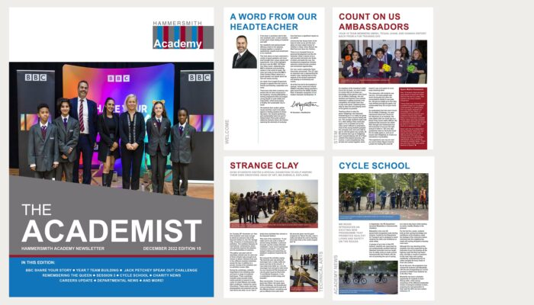

https://www.hammersmithacademy.org/parent-portal/newsletter/

HOW TO APPLY

Please complete the application form which includes a supporting statement. Whilst referencing the Person Specification and Job Description, your supporting statement should show your skills, attributes and abilities to teach in the subject within Hammersmith Academy (no more than 2 x A4 sides - min.11pt font) and give evidential examples to support your points.

Your statement must include the following points:

- How you inspire students to make excellent progress;
- How you will achieve the highest standards in terms of curriculum, teaching and learning.

CVs will not be accepted for this post.

For additional information about Hammersmith Academy please visit our website:
www.hammersmithacademy.org

Closing Date: Monday, 8th January 2024 – 9.00am
Interviews: To be confirmed

Applications from candidates wishing to work on a part-time basis, will be considered.

In accordance with recommendations made by the DfE in Keeping Children Safe in Education 2022, all shortlisted candidates will be subject to an online search. This will help identify any incidents or issues that have happened, and are publicly available online, which Hammersmith Academy will explore with the applicant at interview.

All applications will initially be acknowledged by e-mail. If you have not heard further within two weeks of the closing date you may assume you have not been successful on this occasion.

Hammersmith Academy is committed to safeguarding and promoting the welfare of children and young people and expects all staff and volunteers to share this commitment. This post is subject to an enhanced disclosure from the Disclosure and Barring Service (DBS Check) and the receipt of two satisfactory references.

Hammersmith Academy is an Equal Opportunities employer and does not discriminate on the grounds of any protected characteristics as defined by the Equality Act 2010.

Hammersmith Academy

Vision
To develop highly qualified, aspirational young adults who make outstanding progress and as active citizens take a lead within the community and are committed to giving 100% in everything they do.

Values
We inspire pride and confidence in our students to achieve their full potential. Everyone in the Academy is responsible for modelling a positive and professional attitude at all times.

We create a stimulating and enriching learning environment where high expectations and challenge prepare students for a global society.

We succeed by developing a growth mind-set through the skills of resilience, resourcefulness, reflectiveness and reciprocity.

The HA WAY - HA learners demonstrate:
- Pride and Commitment
- Professionalism and Leadership
- Active citizenship
- Honesty and Reliability
- Respect and Integrity

Hammersmith Academy ensures that students are happy, safe and secure in their learning and develop through a culture of success, into self-confident independent learners who become highly valued members of their community. Strong leadership at all levels challenges underachievement and ensures students make outstanding progress and achieve high standards of attainment.

It is an inspiring and creative place to learn, which is rich in digital and creative media technology that stimulates and develops students’ academic and vocational skills through the promotion of excellence.

Students leaving the academy will have the following profile:
- A strong portfolio of accredited achievement;
- A highly developed sense of responsibility and pride in their own performance;
- Outstanding communication skills, including digital literacy
- Well-developed literacy and numeracy skills
- Strong leadership skills coupled with a professional attitude to enhance employability;
- An ability to work collaboratively and develop team cohesion;
- An aptitude for research, enquiry, problem solving and creativity
- Are actively kind, caring and socially responsible.

Developing character and a growth mind-set - Be better than you thought you could be
Good character development coupled with academic success is essential to a high-quality education. We succeed by developing a growth mind-set through the skills of resilience in the face of challenge, resourceful when solving problems, reflective when evaluating progress and reciprocal when working in teams. To be fearless when striving for excellence and contributing positively to life in a global society.
We want each individual to be better than they thought they could be. We believe everyone is powerful beyond measure and capable of extraordinary achievements. We expect more from ourselves and each other in our drive to be the best and are 100% committed in everything we do. We constantly challenge students to push their limits, to work hard, to be resilient and inspire each other to outstanding success.

We expect the same from all adults. That they are determined and committed to be the best they can be, demonstrate a ‘can do’ attitude and transmit these expectations to the students.

Knowledge is power
Knowledge creates power. First, Intellectual power - primarily through the core disciplines of literacy and mathematics which are the building blocks in accessing a successful life. Second, Economic power - a deep understanding of the links between self-management and problem-solving skills in becoming rounded and grounded in preparation for the world of work and thirdly, Social power - developing our social and moral responsibility as active citizens.

We prepare students for successful lives through a stimulating and engaging curriculum where our practices mirror those found in the wider world of work. Using a broad experiential approach, students are given the opportunity to make choices, take responsibility for their learning and accelerate their interests in greater depth.

Developing a thirst for knowledge through inspirational teaching is powerful. Its value is limitless. It enables students to absorb challenging concepts and develop the skills of critique, analysis and evaluation.

Leading is achieving
Leadership is central to our ethos of success as an individual, a team and a learning organisation. We work closely together to improve. We consistently look to enhance the quality of what we are doing and seek inspiration from inside and outside the Academy.

Our students are future leaders who develop a clear sense of ownership and pride in their own performance which empowers them to support others. We expect students to value and celebrate success and champion their community.

All adults are expected to lead and to build a performance culture. In every action, attitude and expression, they set direction and expectation. Every adult is trusted to act with integrity and take personal responsibility to do the right thing for the students.

